Table S1. The contrasts for lake from the most parsimonious ANCOVA model (Log₂[Abundance] ~ Log₂[Mid of wet weight bin] × season × lake + year) for pelagic abundance size spectra slopes sorted by p-value.
Lake 1 | Lake 2 | Estimate | SE | df | T-ratio | p-value
Michigan | Western Erie | 0.112 | 0.028 | 4283 | 3.96 | 0.00
Superior | Western Erie | 0.079 | 0.028 | 4283 | 2.79 | 0.08
WBLE | Ontario | -0.074 | 0.029 | 4283 | -2.60 | 0.13
Michigan | Central Erie | 0.072 | 0.028 | 4283 | 2.56 | 0.14
Michigan | Huron | 0.055 | 0.023 | 4283 | 2.40 | 0.20
Huron | Western Erie | 0.057 | 0.029 | 4283 | 2.01 | 0.41
Michigan | Eastern Erie | 0.056 | 0.028 | 4283 | 2.00 | 0.41
Western Erie | Eastern Erie | -0.056 | 0.033 | 4283 | -1.70 | 0.61
Michigan | Ontario | 0.038 | 0.023 | 4283 | 1.66 | 0.64
Superior | Michigan | -0.033 | 0.023 | 4283 | -1.44 | 0.78
Superior | Central Erie | 0.039 | 0.028 | 4283 | 1.39 | 0.81
Central Erie | Ontario | -0.034 | 0.028 | 4283 | -1.20 | 0.89
Western Erie | Central Erie | -0.04 | 0.033 | 4283 | -1.22 | 0.89
Superior | Huron | 0.022 | 0.023 | 4283 | 0.96 | 0.96
Superior | Eastern Erie | 0.023 | 0.028 | 4283 | 0.83 | 0.98
Huron | Ontario | -0.017 | 0.023 | 4283 | -0.73 | 0.99
Central Erie | Eastern Erie | -0.016 | 0.033 | 4283 | -0.48 | 1.00
Eastern Erie | Ontario | -0.018 | 0.028 | 4283 | -0.64 | 1.00
Huron | Central Erie | 0.017 | 0.028 | 4283 | 0.60 | 1.00
Huron | Eastern Erie | 0.001 | 0.028 | 4283 | 0.05 | 1.00
Superior | Ontario | 0.005 | 0.023 | 4283 | 0.23 | 1.00

Table S2. Simplified ANCOVA model lake contrast output for the Log₂(Abundance) ~ Log₂(Mid of wet weight bin) × type × lake model, sorted by p-value.
Lake 1 | Lake 2 | Difference | SE | T-ratio | p-value
Michigan | Western Erie | 0.12 | 0.025 | 4.83 | <0.0001
Western Erie | Eastern Erie | -0.12 | 0.027 | -4.45 | 0.0002
Michigan | Central Erie | 0.10 | 0.024 | 4.25 | 0.0004
Central Erie | Eastern Erie | -0.10 | 0.026 | -3.89 | 0.0020
Superior | Western Erie | 0.082 | 0.025 | 3.21 | 0.023
Huron | Western Erie | 0.074 | 0.025 | 3.01 | 0.042
Michigan | Ontario | 0.057 | 0.022 | 2.61 | 0.12
Superior | Central Erie | 0.063 | 0.025 | 2.59 | 0.13
Western Erie | Ontario | -0.063 | 0.025 | -2.54 | 0.15
Huron | Central Erie | 0.056 | 0.024 | 2.37 | 0.21
Eastern Erie | Ontario | 0.056 | 0.024 | 2.33 | 0.23
Michigan | Huron | 0.046 | 0.022 | 2.11 | 0.35
Central Erie | Ontario | -0.045 | 0.024 | -1.88 | 0.50
Huron | Eastern Erie | -0.045 | 0.024 | -1.87 | 0.50
Superior | Michigan | -0.039 | 0.022 | -1.72 | 0.60
Superior | Eastern Erie | -0.037 | 0.025 | -1.53 | 0.73
Superior | Ontario | 0.018 | 0.023 | 0.82 | 0.98
Western Erie | Central Erie | -0.018 | 0.027 | -0.68 | 0.99
Huron | Ontario | 0.011 | 0.022 | 0.52 | 1.00
Superior | Huron | 0.0072 | 0.022 | 0.32 | 1.00
Michigan | Eastern Erie | 0.0012 | 0.024 | 0.05 | 1.00

Table S3. The most parsimonious height ANCOVA model (Height ~ year + season × lake) contrasts for the season and lake interaction sorted by p-value.
Season & Lake 1 | Season & Lake 2 | Estimate | SE | df | T-ratio | p-value
spring, Superior | spring, Western Erie | 2.98 | 0.40 | 121 | 7.49 | <0.0001
spring, Superior | summer, Central Erie | -2.07 | 0.29 | 121 | -7.10 | <0.0001
spring, Superior | spring, Eastern Erie | 3.15 | 0.52 | 121 | 6.06 | <0.0001
spring, Superior | summer, Ontario | -1.65 | 0.28 | 121 | -5.94 | <0.0001
summer, Superior | spring, Huron | 1.92 | 0.28 | 121 | 6.95 | <0.0001
summer, Superior | spring, Western Erie | 3.89 | 0.35 | 121 | 11.19 | <0.0001
summer, Superior | summer, Central Erie | -1.17 | 0.22 | 121 | -5.38 | <0.0001
summer, Superior | spring, Eastern Erie | 4.05 | 0.48 | 121 | 8.42 | <0.0001
spring, Michigan | spring, Western Erie | 2.84 | 0.39 | 121 | 7.23 | <0.0001
spring, Michigan | summer, Central Erie | -2.21 | 0.29 | 121 | -7.77 | <0.0001
spring, Michigan | spring, Eastern Erie | 3.01 | 0.52 | 121 | 5.83 | <0.0001
spring, Michigan | summer, Ontario | -1.79 | 0.27 | 121 | -6.62 | <0.0001
summer, Michigan | spring, Huron | 1.83 | 0.27 | 121 | 6.73 | <0.0001
summer, Michigan | spring, Western Erie | 3.79 | 0.34 | 121 | 11.04 | <0.0001
summer, Michigan | summer, Central Erie | -1.27 | 0.21 | 121 | -6.02 | <0.0001
summer, Michigan | spring, Eastern Erie | 3.95 | 0.48 | 121 | 8.27 | <0.0001
spring, Huron | summer, Western Erie | -2.04 | 0.32 | 121 | -6.31 | <0.0001
spring, Huron | summer, Central Erie | -3.09 | 0.29 | 121 | -10.86 | <0.0001
spring, Huron | summer, Eastern Erie | -1.69 | 0.31 | 121 | -5.49 | <0.0001
spring, Huron | summer, Ontario | -2.67 | 0.27 | 121 | -9.86 | <0.0001
summer, Huron | spring, Western Erie | 3.05 | 0.35 | 121 | 8.73 | <0.0001
summer, Huron | summer, Central Erie | -2.00 | 0.22 | 121 | -9.06 | <0.0001
summer, Huron | spring, Eastern Erie | 3.22 | 0.48 | 121 | 6.66 | <0.0001
summer, Huron | summer, Ontario | -1.58 | 0.20 | 121 | -7.80 | <0.0001
spring, Western Erie | summer, Western Erie | -4.00 | 0.39 | 121 | -10.39 | <0.0001
spring, Western Erie | spring, Central Erie | -3.46 | 0.43 | 121 | -8.07 | <0.0001
spring, Western Erie | summer, Central Erie | -5.06 | 0.35 | 121 | -14.29 | <0.0001
spring, Western Erie | summer, Eastern Erie | -3.66 | 0.37 | 121 | -9.81 | <0.0001
spring, Western Erie | spring, Ontario | -2.29 | 0.42 | 121 | -5.51 | <0.0001
spring, Western Erie | summer, Ontario | -4.64 | 0.34 | 121 | -13.53 | <0.0001
summer, Western Erie | spring, Eastern Erie | 4.16 | 0.51 | 121 | 8.18 | <0.0001
spring, Central Erie | spring, Eastern Erie | 3.62 | 0.54 | 121 | 6.67 | <0.0001
summer, Central Erie | spring, Eastern Erie | 5.22 | 0.49 | 121 | 10.75 | <0.0001
summer, Central Erie | summer, Eastern Erie | 1.40 | 0.26 | 121 | 5.48 | <0.0001
summer, Central Erie | spring, Ontario | 2.77 | 0.32 | 121 | 8.79 | <0.0001
spring, Eastern Erie | summer, Eastern Erie | -3.82 | 0.50 | 121 | -7.64 | <0.0001
spring, Eastern Erie | summer, Ontario | -4.80 | 0.48 | 121 | -10.05 | <0.0001
spring, Ontario | summer, Ontario | -2.35 | 0.30 | 121 | -7.76 | <0.0001
summer, Superior | spring, Ontario | 1.60 | 0.31 | 121 | 5.20 | 0.0001
summer, Michigan | spring, Ontario | 1.50 | 0.30 | 121 | 4.96 | 0.0002
spring, Huron | spring, Western Erie | 1.96 | 0.39 | 121 | 5.00 | 0.0002
summer, Western Erie | spring, Ontario | 1.71 | 0.35 | 121 | 4.90 | 0.0002
spring, Central Erie | summer, Central Erie | -1.60 | 0.33 | 121 | -4.84 | 0.0003
spring, Eastern Erie | spring, Ontario | -2.45 | 0.53 | 121 | -4.60 | 0.0008
summer, Michigan | summer, Ontario | -0.85 | 0.19 | 121 | -4.42 | 0.002
spring, Huron | spring, Eastern Erie | 2.13 | 0.52 | 121 | 4.13 | 0.01
summer, Eastern Erie | summer, Ontario | -0.98 | 0.24 | 121 | -4.08 | 0.01
summer, Eastern Erie | spring, Ontario | 1.37 | 0.34 | 121 | 4.07 | 0.01
spring, Huron | spring, Central Erie | -1.49 | 0.37 | 121 | -4.00 | 0.01
summer, Superior | summer, Huron | 0.83 | 0.21 | 121 | 3.96 | 0.01
spring, Huron | summer, Huron | -1.09 | 0.28 | 121 | -3.90 | 0.01
summer, Western Erie | summer, Central Erie | -1.06 | 0.27 | 121 | -3.87 | 0.01
summer, Superior | spring, Michigan | 1.04 | 0.28 | 121 | 3.77 | 0.02
summer, Superior | summer, Ontario | -0.75 | 0.20 | 121 | -3.77 | 0.02
spring, Central Erie | summer, Ontario | -1.18 | 0.32 | 121 | -3.70 | 0.02
summer, Michigan | summer, Huron | 0.74 | 0.20 | 121 | 3.61 | 0.03
spring, Michigan | summer, Western Erie | -1.16 | 0.32 | 121 | -3.59 | 0.03
summer, Huron | summer, Western Erie | -0.95 | 0.27 | 121 | -3.53 | 0.04
spring, Michigan | summer, Michigan | -0.95 | 0.27 | 121 | -3.48 | 0.04
spring, Superior | summer, Superior | -0.90 | 0.28 | 121 | -3.18 | 0.10
spring, Superior | summer, Western Erie | -1.02 | 0.33 | 121 | -3.09 | 0.12
spring, Superior | spring, Huron | 1.02 | 0.34 | 121 | 3.01 | 0.15
spring, Central Erie | spring, Ontario | 1.17 | 0.40 | 121 | 2.94 | 0.17
spring, Superior | summer, Michigan | -0.81 | 0.28 | 121 | -2.89 | 0.20
spring, Michigan | summer, Eastern Erie | -0.81 | 0.31 | 121 | -2.64 | 0.33
spring, Michigan | spring, Huron | 0.88 | 0.33 | 121 | 2.64 | 0.33
summer, Huron | spring, Ontario | 0.77 | 0.31 | 121 | 2.47 | 0.44
summer, Western Erie | summer, Ontario | -0.64 | 0.26 | 121 | -2.46 | 0.45
summer, Huron | summer, Eastern Erie | -0.60 | 0.25 | 121 | -2.41 | 0.48
spring, Superior | summer, Eastern Erie | -0.67 | 0.32 | 121 | -2.14 | 0.67
summer, Central Erie | summer, Ontario | 0.42 | 0.21 | 121 | 2.01 | 0.76
spring, Superior | spring, Ontario | 0.70 | 0.36 | 121 | 1.91 | 0.82
spring, Michigan | spring, Central Erie | -0.61 | 0.37 | 121 | -1.64 | 0.93
spring, Michigan | spring, Ontario | 0.56 | 0.36 | 121 | 1.55 | 0.96
summer, Western Erie | spring, Central Erie | 0.55 | 0.36 | 121 | 1.50 | 0.97
summer, Superior | spring, Central Erie | 0.43 | 0.32 | 121 | 1.33 | 0.99
spring, Superior | spring, Central Erie | -0.47 | 0.38 | 121 | -1.25 | 0.99
summer, Huron | spring, Central Erie | -0.40 | 0.33 | 121 | -1.23 | 0.99
summer, Western Erie | summer, Eastern Erie | 0.34 | 0.30 | 121 | 1.15 | 1.00
summer, Michigan | spring, Central Erie | 0.33 | 0.32 | 121 | 1.05 | 1.00
summer, Superior | summer, Eastern Erie | 0.23 | 0.25 | 121 | 0.93 | 1.00
spring, Huron | spring, Ontario | -0.32 | 0.36 | 121 | -0.90 | 1.00
summer, Michigan | summer, Western Erie | -0.21 | 0.26 | 121 | -0.81 | 1.00
spring, Superior | spring, Michigan | 0.14 | 0.34 | 121 | 0.41 | 1.00
spring, Superior | summer, Huron | -0.07 | 0.29 | 121 | -0.25 | 1.00
summer, Superior | summer, Michigan | 0.10 | 0.20 | 121 | 0.49 | 1.00
summer, Superior | summer, Western Erie | -0.11 | 0.27 | 121 | -0.43 | 1.00
spring, Michigan | summer, Huron | -0.21 | 0.28 | 121 | -0.75 | 1.00
summer, Michigan | summer, Eastern Erie | 0.13 | 0.24 | 121 | 0.55 | 1.00
spring, Western Erie | spring, Eastern Erie | 0.16 | 0.56 | 121 | 0.29 | 1.00
spring, Central Erie | summer, Eastern Erie | -0.20 | 0.35 | 121 | -0.58 | 1.00

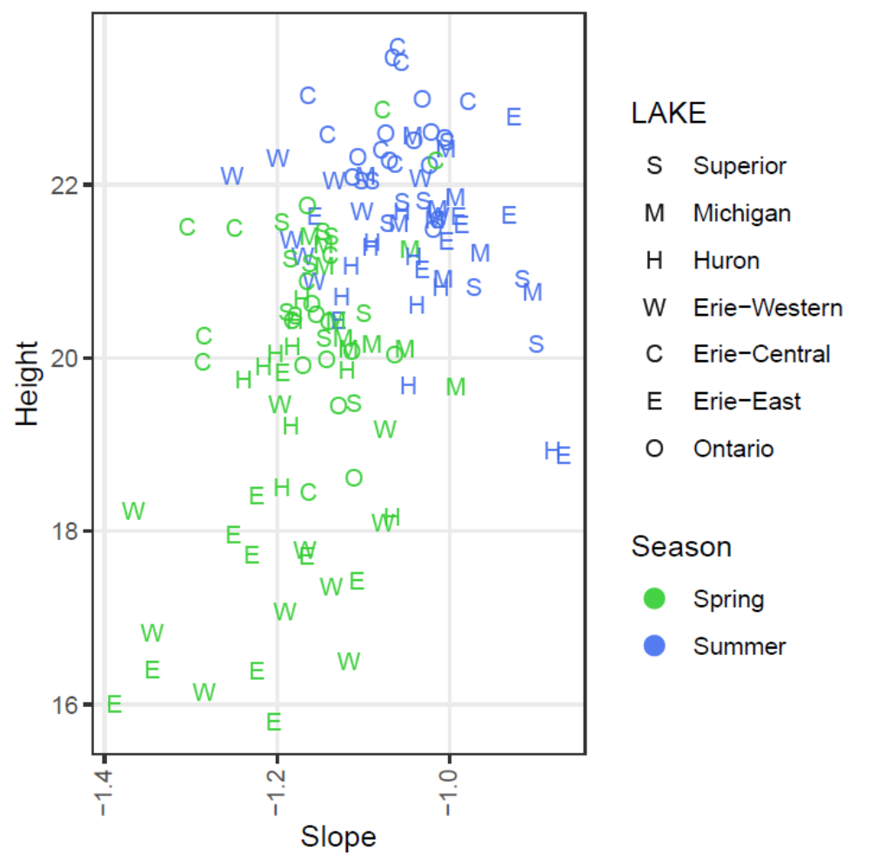
Fig. S1. Height and slope of all pelagic abundance size spectra, with lakes plotted as symbols and seasons as colors.

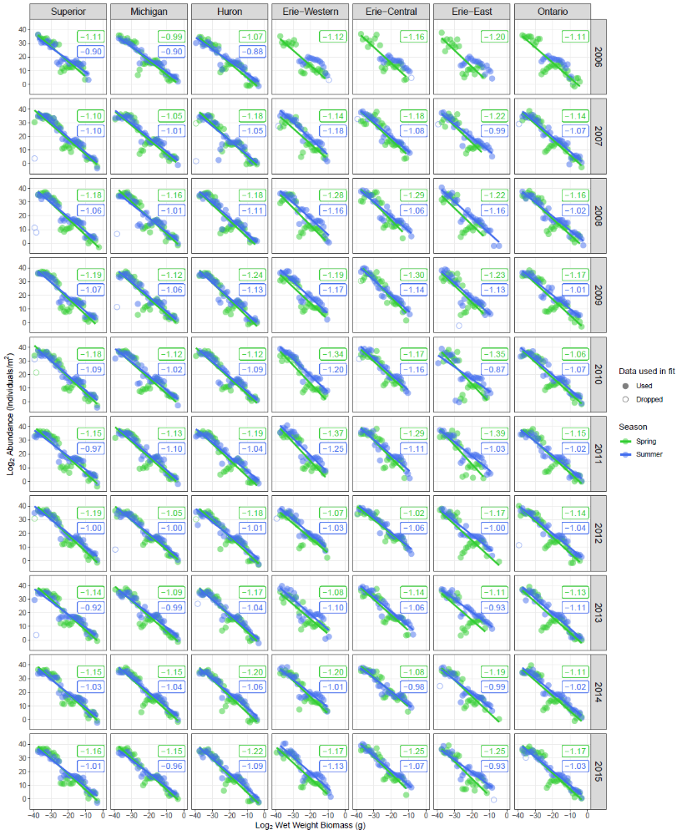
Fig. S2. Pelagic abundance size spectra plotted for each lake and year. The linear fits are plotted and the slopes reported in each plot panel. Color always designates the season. For size spectra without pelagic data no fit is applied or reported.
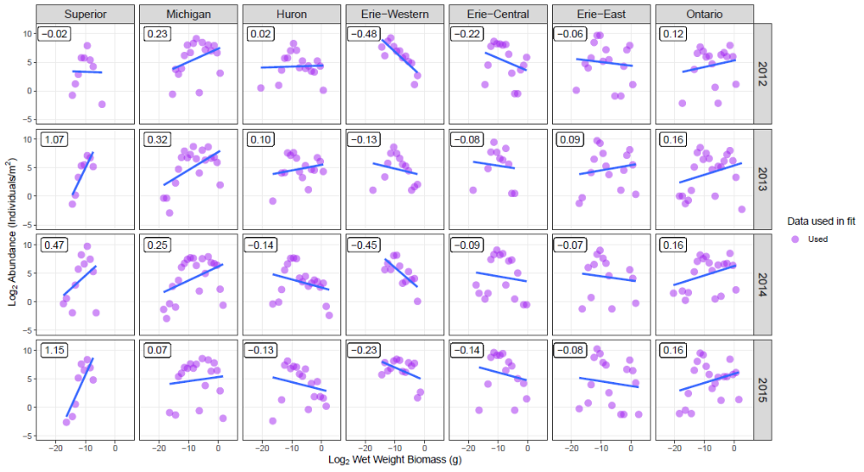
Fig. S3. Benthic abundance size spectra for each lake and year, all data were used in the creation of linear fits (blue line). Estimated slopes are displayed on each plot.

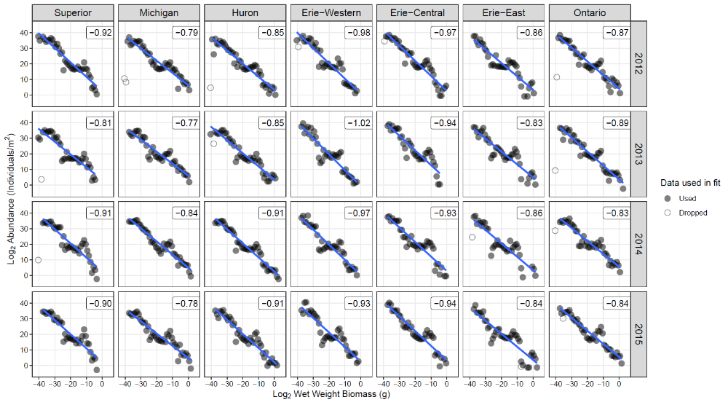
Fig. S4. Abundance size spectra of combined benthic and pelagic data, and whether the data were used in creation of linear fits (blue line). Estimated slopes are displayed on each plot.

